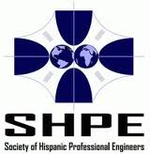
at Escuela Avancemos Academy
Welcome to Family Engineering Night
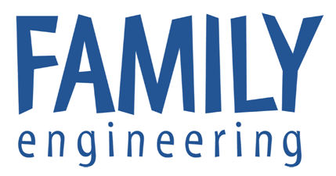


Parents ~ Please Read

- FREE dinner 5:00-6:00 pm in cafeteria.

- Families attend (3) 35-minute activities from 6:00–6:35 pm, 6:40–7:15 pm, 7:20-7:55 pm.

- Families may attend any of the activities listed below together, or send children to the activity for their age group, and parents go with their youngest children.

Activities for Kindergarten – 2nd Grade Students & Families
1. Launcher Room 216
Become a mechanical engineer and design a “launcher” machine that can propel objects. Can your launcher make the marshmallow land exactly where you want?

Presenter: Gabriela Shirkey, Michigan Tech Graduate, Scientific & Technical Communication,
Society of Hispanic Professional Engineers (SHPE)

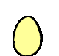
2. Brain Saver Room 218

Why do we need to wear helmets for some activities? Pretend your brain is an egg and design a helmet that will protect your egg (head) in a crash.

Presenter: Uzi Mendez, PhD Student, Biomedical Engineering, University of Michigan, Society of Hispanic Professional Engineers (SHPE)

3. Engineering Activity Stations Cafeteria Room 200
(2 activities per table; one Spanish & one English; 12 different short activity stations)
Presenter: Joan Chadde, Center for Science & Environmental Outreach, Michigan Technological University

~ OVER ~
Activities for 3rd-5th Grade Students & Families
1. Bright Ideas Room 208
How do flashlights work? Can you light a light bulb using wires & batteries?
Now design your own reading light that you can use without holding it!

Presenter: Zoe Miller, M. S. Student, Department of Environmental Engineering,
Michigan Technological University, Society of Hispanic Professional Engineers (SHPE)


2. Give Me a Hand Room 210

Imagine having no hands... Holding a pencil or tying your shoes would be very challenging. Become a biomedical engineer and design a simple prosthetic hand – a device that can be used to pick up objects.

Presenter: Michael Briseno, Michigan Tech Student, Biomedical Engineering,

Society of Hispanic Professional Engineers (SHPE)

3. Engineering Activity Stations Cafeteria Room 200
(2 activities per table; one Spanish & one English; 12 different short activity stations)
Presenter: Joan Chadde, Center for Science & Environmental Outreach, Michigan Technological University
- All the Right Tools  - Arches  - Domino Diving Board  - Glue is the Clue  - Happy Feet  - Inspired by Nature  - Learning from Failure  - Let’s Communicate | 9. Make It Loud  10. My Foot, Your Foot  11. Shifting Shapes  12. Solid Ground  13. Thrill Seekers  14. Tumbling Tower  15. Who Engineered It?

Conducted by Society of Hispanic Professional Engineers (SHPE) Student Chapters
with funding from John Deere and Michigan Technological University





