This tool focuses on 4 Elements of Implementation and 4 Stages of Development. It provides guidance questions and resources for the District or School in each of these areas.

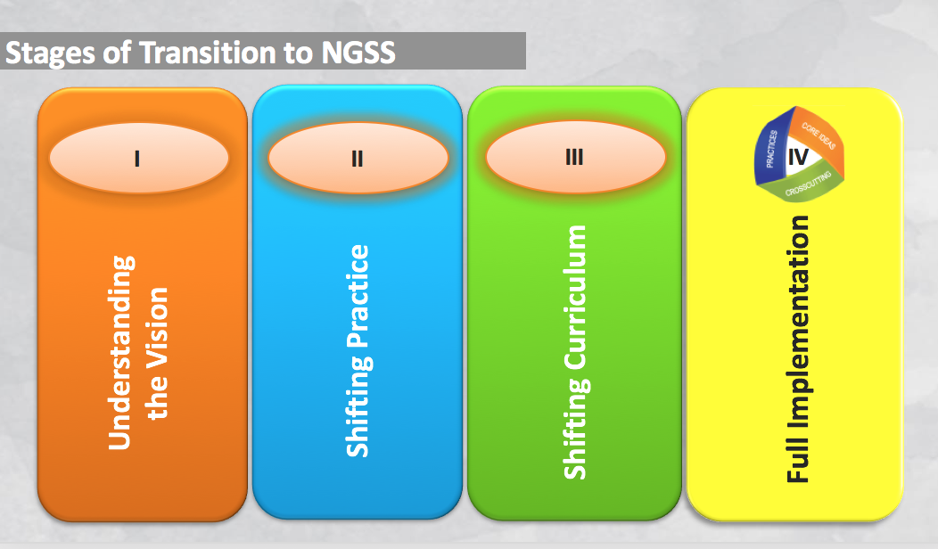

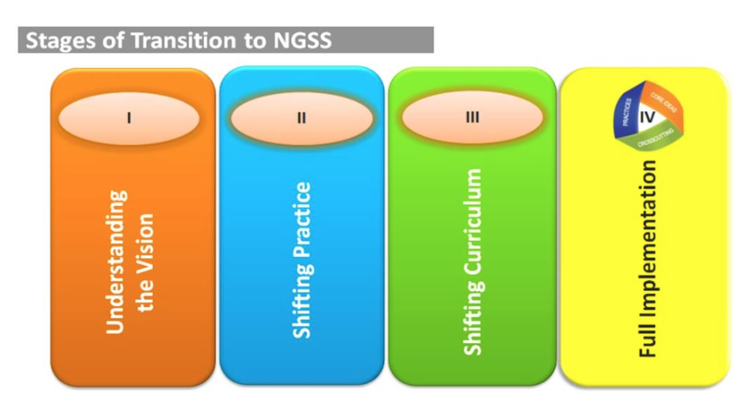

|  |  |
| --- | --- |
| [**Teacher & Leadership Learning**](https://www.nap.edu/read/18802/chapter/6) | |
| [**Recommendation 5**](https://www.nap.edu/read/18802/chapter/2#3) | **Train, identify, and designate leadership teams (PLCs, Committees or Departments) to lead implementation efforts.** |
| **Questions:**   * Who are the local science leaders? * How will the teams be organized? Whole district? Grade level teams? Building level departments? * How often will groups or subgroups meet? * What professional development and support is needed to build capacity? | |
| **Resources:**  [NGSX](http://www.ngsx.org/)  [Professional Development that Supports NGSS: STEM Teaching Tools](http://stemteachingtools.org/brief/13)  [Professional Development Priorities: STEM Teaching Tools](http://stemteachingtools.org/brief/9) | |
| [**Recommendation 6**](https://www.nap.edu/read/18802/chapter/2#4) | **Develop a comprehensive, multiyear plan to support teachers’ and administrators’ learning and progress toward implementation.** |
| **Questions:**   * 4 Phases of Implementation:   + Understand the Vision🡪Shift Classroom Practices🡪Shift and Align Curriculum   + Full Implementation * How will the leadership team prioritize critical implementation steps? * What local systems are in place that support the vision? * How will the team communicate the plan to the stakeholders? * How will resource allocation be determined? * What professional development and support is needed? | |
| **Resources:**  [4 Year Strategic Planning Timeline (Fill In)](http://www.resa.net/downloads/science/strategic_plan_blank_20151207_140309_15.pdf)  [Guide to Implementing NGSS](https://www.nap.edu/read/18802/chapter/1)  [MDE Science Homepage](http://www.michigan.gov/mde/0,4615,7-140-28753_64839_65510-339833--,00.html) | |



|  |  |
| --- | --- |
| [**Instruction (page 1)**](https://www.nap.edu/read/18802/chapter/5) | |
| [**Recommendation 1**](https://www.nap.edu/read/18802/chapter/2#2) | **Establish, support and communicate a vision for 3-Dimensional K-12 Science as outlined in the NRC Framework and Michigan Science Standards.** |
| **Questions:**   * What instructional models support the shift from “learn about” topics to “figure out” phenomena? * How will the leadership communicate these shifts to all stakeholders? | |
| **Resources:**  [What’s Different: STEM Teaching Tool](http://stemteachingtools.org/brief/14)   * [[Ambitious Science Teaching](http://stemteachingtools.org/brief/14)](http://www.resa.net/downloads/science__chemistry/ambitious_science_teaching_20151103_135354_12.docx)   [Science Instruction Blueprint Tool](https://drive.google.com/drive/folders/0B1EP8D-dGMIVbWlsZmRXUlVZSkE)  [Instructional Models for Science: STEM Teaching Tool](http://stemteachingtools.org/brief/4) | |
| [**Recommendation 2**](https://www.nap.edu/read/18802/chapter/2#2) | **Provide support for teachers and administrators to make incremental, consistent progress toward the vision.** |
| **Questions:**   * How does the current teacher evaluation model support the instructional shifts in science? (See also, Recommendation 3) * How do the instructional shifts align with other district and/or building initiatives? * What professional development and support is needed to understand the vision and shift practice? | |
| **Resources:**  [Science Instruction Blueprint Tool](https://drive.google.com/drive/folders/0B1EP8D-dGMIVbWlsZmRXUlVZSkE) | |



|  |  |
| --- | --- |
| **Instruction (page 2)** | |
| [**Recommendation 3**](https://www.nap.edu/read/18802/chapter/2#3) | **Shift classroom culture toward 3-Dimensional student-centered inquiry as described in the Michigan Science Standards.** |
| **Questions:**   * Is student work in science class focused on explaining phenomena or solving problems? * Are students engaged in productive talk? * Are students engaged in using practices and cross-cutting concepts? * Is teacher work focused on “fixing” student misconceptions or recognizing, building, and responding to the range of student ideas about science? | |
| **Resources:**  [Beyond Misconceptions: STEM Teaching Tool](http://stemteachingtools.org/brief/37)  [Learn Science through Productive Talk: STEM Teaching Tool](http://stemteachingtools.org/brief/6)  [Video Case Studies: Ambitious Science Teaching](http://ambitiousscienceteaching.org/video-series/)  [Video Case Studies: Inquiry Project / Science Talk](http://inquiryproject.terc.edu/) | |
| [**Recommendation 4**](https://www.nap.edu/read/18802/chapter/2#3) | **Establish assessment as an integral part of instruction: embedded formative assessments and summative performance tasks.** |
| **Questions:**   * What formative assessment strategies are currently used in classrooms? * How are performance tasks used in summative assessments? * What kinds of rubrics are used to help teachers assess student performance? * What processes are in place for teachers to review student work? | |
| **Resources:**  [Using Summary Charts to Press for Evidence and Build Coherence](https://www.teachingchannel.org/blog/ausl/2016/02/04/using-summary-charts-to-press-for-evidence-and-promote-coherent-science-instruction-8-tips/)  [Assessment Series: STEM Teaching Tools](http://stemteachingtools.org/tgs/Assessment) | |



|  |  |
| --- | --- |
| [**Curriculum Materials**](https://www.nap.edu/read/18802/chapter/7) | |
| [**Recommendation 9**](https://www.nap.edu/read/18802/chapter/2#5) | **Provide teachers with training, guidelines, and tools to revise or adapt existing curriculum materials in support of the vision.** |
| **Questions:**   * What materials are currently in place? Can current materials be aligned or adapted? * What evaluation tool will guide the decision making process? * What is the timeline for pilot, adaption, or adoption? * What is the budget for consumables as student engage in science & engineering practices? | |
| **Resources:**  [Adapting Existing Curriculum for NGSS: STEM Teaching Tools](http://stemteachingtools.org/brief/5)  [5 Tools for Translating NGSS into Instruction](http://www.amnh.org/explore/curriculum-collections/five-tools-and-processes-for-ngss/) | |
| [**Recommendation 10**](https://www.nap.edu/read/18802/chapter/2#5) | **Facilitate decision making processes to determine the scope and sequence.** |
| **Questions:**   * Will K-5 units be organized by Topic or by the adopted curricula? * Will 6-8 courses be organized by Topic, Conceptual Progression, or Domain Specific Model? * Will 9-12 courses be organized by Topic, Conceptual Progression, or Domain Specific Model? | |
| **Resources:**  [Sample Course Mapping for Michigan](http://www.ngssmichigan.com/uploads/2/8/9/0/28905139/draft_course__model_resource_-5-23-13_0.pdf)  [Course Mapping for MS/HS: Appendix K](http://www.nextgenscience.org/sites/default/files/Appendix%20K_Revised%208.30.13.pdf) | |
| [**Recommendation 11**](https://www.nap.edu/read/18802/chapter/2#5) | **Establish a clear set of measures and tools to evaluate whether new materials are consistent with the vision.** |
| **Questions:**   * What materials will be considered for adoption? * What is the local curriculum adoption process? | |
| **Resources:**  [EQUiP Rubric for Science Lessons and Units](http://www.nextgenscience.org/resources/equip-rubric-lessons-units-science)  [Evaluating Curriculum Materials for NGSS: STEM Teaching Tools](http://stemteachingtools.org/brief/23) | |



|  |  |
| --- | --- |
| [Assessment](https://www.nap.edu/read/18802/chapter/8) | |
| [**Recommendation 13**](https://www.nap.edu/read/18802/chapter/2#6) | **Create a balanced system of assessments to monitor student progress toward the performance expectations.** |
| ../Desktop/Screenshots/CpbWWFXWcAMwgh1.jpg**Questions:**   * How will student learning be assessed at the Classroom level? Building level? District level? * What evidence of learning is being collected? * How is progress reported? | |
| **Resources:**  [A Balanced Assessment System: STEM Teaching Tools](http://stemteachingtools.org/brief/34)  [Assessment Series: STEM Teaching Tools](http://stemteachingtools.org/tgs/Assessment) | |
| **Recommendation 14** | **Support teachers’ use of appropriate formative assessment strategies of student thinking to inform ongoing instruction. (See Recommendation 4)** |
| **Questions:**   * What formative assessment strategies are currently used in classrooms? * How can teacher’s use science and engineering practices + productive talk strategies to inform instruction and guide student learning? | |
| **Resources:**  [Formative Assessments for NGSS: STEM Teaching Tools](http://stemteachingtools.org/brief/18) | |